
Founded for the Evolution: Science - Medicine - Culture - Education - Environment - Agriculture - Industry - Society : the Life

SORIZ AND SORGREED
high effective hybrids of sorghum

by
Doctor of agriculture
G. A. Moraru

© FULMINA HUMAN RESOURSES

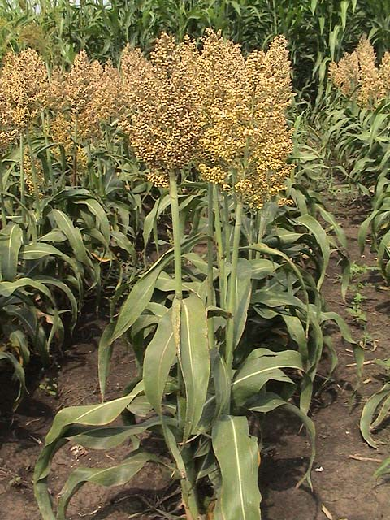

SORIZ - SORGHUM GRAIN PLANT TO SIMILARLY RICE

Soriz is a new strain of sorghum grains mayor created in the former USSR in the 80s of last century the Research Institute for Maize and Sorghum in Moldova (RM), by crosses gradual plant sorghum (Sorghum) grain with grass Sudan and related species in Africa. The biochemical composition and character of the grain fracture created this plant are like a grain of rice (Oryza), and therefore it was decided to name this plant - like rice, sorghum (Sorghum oryzoidum), or by combining these words - Soriz in Romanian and other languages that use Latin characters (EN, FR, ES, PT, etc.) and in languages with Cyrillic - Coриз (RU, UA, BY, KZ, etc.).
Author of the originally homologated improvement and the first hybrids of this plant and the name Soriz is the doctor of agriculture Gheorghe Moraru.
Currently there are four hybrids Soriz homologated local selection, including Porumbeni Pişcevoi 1 and 6 in RM, Porumbeni 6 and 3 Porumbeni oxamic in Ukraine and the Russian Federation. Sasmita hybrid 3 is tested by the State Commission of Moldova.
According to morphological peculiarities Soriz plant is like grain sorghum plant and is characterized by increased resistance to drought (up to 2 to 3 weeks), supports saline soils than maize and is unpretentious to soil fertility. Soriz supports high temperature air on background lengthy drought, other grasses in these conditions become fatal. In forming a unit of dry matter Soriz consumes 25-30% less moisture than maize and 1.5 less than rice.
Soriz hybrids with waist 110-140 cm grown under traditional technology of sorghum grain with the use of machinery and aggregates for growing corn. Compared to feed sorghum hybrids and varieties, Soriz have more intensive filling and drying grain and grain moisture at harvest is close to the set of approved standards. Homologated hybrids are resistant to lodging, adapt mechanized cultivation, including harvesting combines grain cereals intended for the first group.
The hybrid Pişcevoi 1 during 6 years of contest examination demonstrated productivity of 8.71 t/ha. Average production of hybrid Pişcevoi one test of RM sectors within several years was on average 6.5 t/ha. In terms of production it was proven that if cultivation and harvesting technology respects the set terms the production of soriz is like the corn, but in dry years, especially in the southern districts of Moldova it exceeds the maize harvest on 2 to 3 t/ha of grain. The harsh weather conditions in the summer of 2012, the driest in the last 60 years, the hybrid Pişcevoi 1 demonstrated production of 3.6 t/ha grain, while corn in these conditions didn't formed grains per cob.

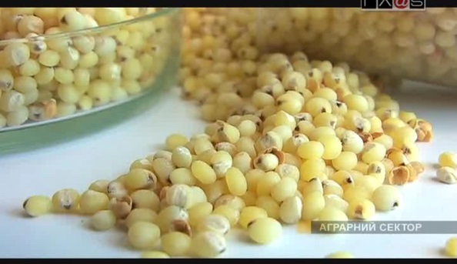
Image 1. Soriz beans

Soriz beans are bare, without tape, white-yellow and oval. Depending on growing conditions and the specific variety, the consistency of the Soriz hybrids grains is glassy (cross glassy surface over 3/4), or half glassy (1/2 -1/3 of the surface). Weight of 1000 grains is 32-36 g, the protein content in grains from 10.5 to 13.4%, fat 3.7 to 4.05 and 65.2 to 75.6% starch. As result of the carried out researches in sectoral research institutes Soriz grains were highly appreciated as a raw material for feed concentrates, preparing different food linings, including many original and dietary.
The cereal out of Soriz beans is oval and light-yellow. The protein content is 9.4 to 10.6% (rice 6.5 to 8.5%), fat 0.2 to 0.5%, starch 82-88%. The cereal efficiency reaches 75-82%. Positive results were obtained in the manufacture of semolina from Soriz, reaching up to 60% efficiency, which due to the content of amylopectin (rice starch) and lack of gluten in perspective can successfully replace wheat semolina (yield 0.3 to 0.7 % of flour) to be widely used for infants and mature people allergic to gluten (celiac patients).
The high content of trace elements, vitamins and iodine as well as fats easily assimilated to the human body, raises the value of groats of Soriz at the highest level, contributing positively to the elimination of harmful substances from the body and reduce the content of cholesterol, which ensures reducing risks cardiovascular diseases.
In food are used whole and ground groats, meal and flour of Soriz. The cereals are cooked in water, milk or meat broth with different consistency. To accelerate cooking, groats soften or fried. Soaking in water is made at room temperature not less than 2 hours. Porridge made from groats subjected to prior softening gets a white and soft consistency. Roasting and drying is carried out in an oven in a layer of 4-5 cm at 110 -115 ° C with periodic mixing. Groats fried porridge cook faster and has a softer and crumblier consistency. Consistency depends on the ratio of liquid porridge and cereals. Friable porridge cooks the proportion of 4:1, and the viscous 5:1. The increase in the coefficient of boiling grits reach 4.9 to 5.1.
Soriz groats are rich of minerals and are useful in the preparation of various kinds of seals and food, including dietary and delicious sweets. Porridges kept in the refrigerator several days and remain crumbly consistency retains both tasty and cold and hot. This priority can successfully be used to simplify serving breakfast in kindergartens, schools, hospitals and workers near their working place, mixing them with milk or other edible components.
Positive results were obtained using the Soriz in culinary flour, baking bread (adding up to 30%), biscuits and especially for making pancakes.
The by-product after the grain refinement called powder contains up to 21% protein, 18% fat, 35% starch and is a valuable component for the manufacture of compound feed.

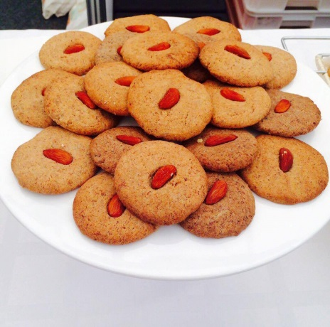
Image 2. Gluten Free Cookies from Soriz flour

Positive results are obtained by using Soriz grain for feeding animals, and especially birds. Hens breded with Soriz grow healthier and lay throughout the year. Besides the production of compound feed for livestock containing increased tocopherol (youth vitamin - E) Soriz was shown advantageous for the manufacture of beer and alcohol. Proceeding from results of investigations at beer plant in Chisinau - "EFES VITANTA" based on hybrid Soriz grain feedstock in manufacture a new beer brand "ARAM " was registered in Moldova. Obtaining top quality alcohol and yield increased from a ton of Soriz beans compared to other cereals, it has been confirmed in alcohol plant in the town of Comrat. This can become a prestigious production of grain and starch that dominate amylopectin (upper fraction of starch from rice), that much better assimilate the human and animal bodies.
Quality groats, meal and flour of Soriz, and products derived from them, largely depends on the quality of the grain collected. In this connection a strict adherence to technological procedures is required, especially on the rates of fertilizers and plant protection doses admitted. Equally important is the timely implementation of measures against sparrows and mice in crop of Soriz, removing off type plants from them, harvest the grain before the arrival of rainy weather and frost, removing operative impurities vegetable harvest grain from combines and conditioning grain moisture at 13-14% standard requirements.
Compared to corn, Soriz seeds are small and therefore resembles the optimal depth of 3-4 cm binding layer wet crushing.
In conclusion, we can say that due to its biological beneficial to the Soriz plants are in high demand and contemporary (at the period of global warming) to ensure stable operation of agriculture under frequent droughts and considering the perspective of the widespread use of primary produce of this crop in many branches of domestic production of the agroindustry sector. It is important that the grain of Soriz grown in Moldova can become in coming years a product to be exported, primarily in Arab countries and in Africa, where grain sorghum and rice from the past are traditional bread for every day for the native population.
The author of Soriz hybrids and of this publication is the head of the IGPPP, Senior Research Scientist, Doctor of agriculture G. A. Moraru.

NEW TYPE OF SWEET SORGHUM HYBRID – SORGREED

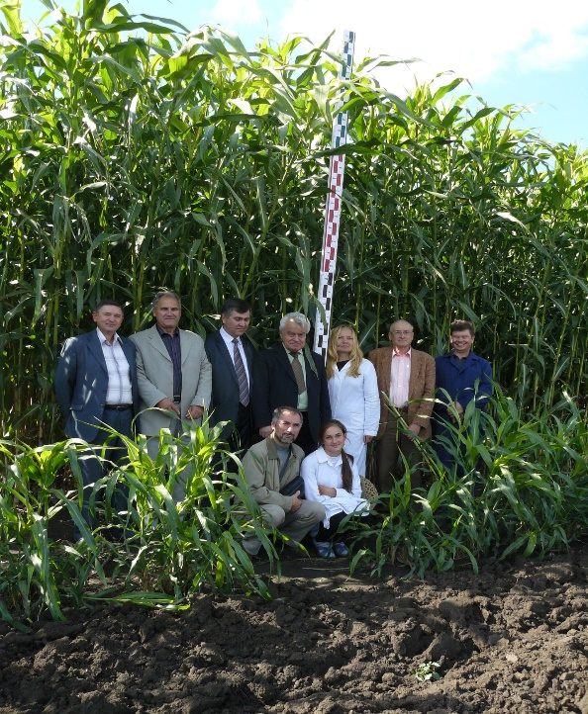
FOR THE PRODUCTION OF FOOD, FORAGE AND BIOENERGY RESOURCES

Professionals of the Republic of Moldova (RM) have created through the traditional selection methods sweet sorghum hybrids, which according to their morphological and agronomic properties: stalk thickness 30-45 mm and height 3.7-4.5 m, and larger leaves size, fibre content of 35-38% and sugar amount in the stalk juice of up to 16-20%, etc., are analogous to sugarcane (Table 1) and may be referred to a new variety of sweet sorghum - sorghum reed, or abbreviated - Sorgreed (EN), and, respectively, Sorgreed in Romanian and other languages, which use the Latin letters (ro., fr., es., pt., etc.), and in Cyrillic languages - Cоргрид (ru., ukr., bel., kaz., etc). Of these, the hybrids Porumbeni 4, Porumbeni 5, SASM 1 and SASM 2 are regionalized in Moldova and other countries. Such hybrids are created by the original combination of the parental forms genes, selected for this purpose, thus ensuring the manifestation of heterosis effect in the first generation of up to 2-2.5 times, with the formation of large biomass harvest of up to 80-90 t/ha in dry farming conditions and over 130-140 t/ha under irrigated conditions. The hybrid Porumbeni 4 in the international testing in the EU became the leader of biomass productivity in 2008 with the harvest of 184 t/ha.
Compared to sugarcane (Annex 1), the vegetation period of these hybrids is 3-4 times shorter, and the plants use the soil moisture 7-8 times and the fertilizer - 2-3 times more efficiently, tolerate soil salinity in a satisfactory way, are not attacked by diseases and pests, resist to stem bending in case of strong winds and long delay in harvesting, as well as adapt well to mechanical harvesting. The method of getting this type of sorghum hybrids is proprietary.
Scheme for obtaining food, forage, bioenergy resources and household materials from biomass sorghum is shown in Fig. 1. Thus, you may obtain from 100 tons of these hybrids biomass: a) through processing in the sugar cane processing line - up to 50-55 tons of juice (must) with the sugar content of 14-16% and 25 - 30 t of dry biomass - bagasse, or b) through the ensilaging - fodder in the amount of 19-23 t of forage units, or more than 25 000 m³ of biogas. Processing of the juice extracted ensures 4.5-5 t/ha of bioethanol or 8-10 t/ha of edible sweet syrup that is similar with honey by its quality, and is capable of successfully replacing the edible sugar in cooking, producing beverages and ice-cream. From 30 tons of sorghum bagasse, you may obtain 16 to 18 thousand m³ of biogas or pellets for the production of 15-17 thousand kWh of electricity and about the same amount of heat energy. As the result of processing through pyrolysis of the dry biomass, gathered from 1 irrigated hectare, you may obtain up to 11 t of biodiesel (Fig. 1, position A-4-2) or 18 t of bio gasoline (position A-4-1). The technology of pyrolysis for producing the gasoline from crushed wood was developed in Canada, the USE and other countries.
During one growing season, the Sorgreed hybrids absorb from atmosphere up to 55 t of CO2, while as the middle latitudes deciduous forest – up to 16-18 t/ha/year. Decomposition of roots (dry mass reaches up to 14-16 t/ha/year) improves soil fertility by providing a positive balance of humus of up to 1.5 - 2 t/ha/year. Like all sorghum crops, this type of hybrid is characterized by increased resistance to continuous drought of up to 2-3 weeks and, compared to other cultures, uses climate resources more efficiently (solar radiation, warmth, soil fertility and moisture). When the Sorgreed hybrids are cultivated under irrigation, monoculture is possible. If the irrigation is absent, crop rotation should be maintained: Sorgreed - peas (other beans) - winter wheat - Sorgreed.
The cultivation technology for the Sorgreed hybrids is similar to the silage maize cultivation technology, since the sowing and plants handling process are carried out with the same set of machinery and equipment. Since the Sorgreed hybrids have extremely high and thick stalks, their harvesting is possible only with the sugarcane-harvesting machines by German company KRONE - "BIG X", the productivity of which is 3800 tons of silage in 11 hours.
Biomass of these hybrids, grown under the conditions of various areas of the RM, was used to obtain: bioethanol, glucose syrup, food, complete feed and energy valuable. Currently, technical and technological documentation is issued for some of the products listed, as well as the seed-producing for parental forms and first-generation seeds cultivation were organized. The cost of 1 ton of these hybrids biomass, grown under the conditions of the Republic of Moldova and transported to the processing unit, makes up 105 MDL ($ 9.35), according to prices as at 2011.
The author of Sorgreed hybrids and of this publication is the head of the IPPEA Sorghum Crops Laboratory ASM, doctor of agriculture G. A. Moraru
Flow-chart for the processing of vegetative mass of sweet sorghum into food, feed and bioenergy resources and materials of households’ destination.
Fig. 1

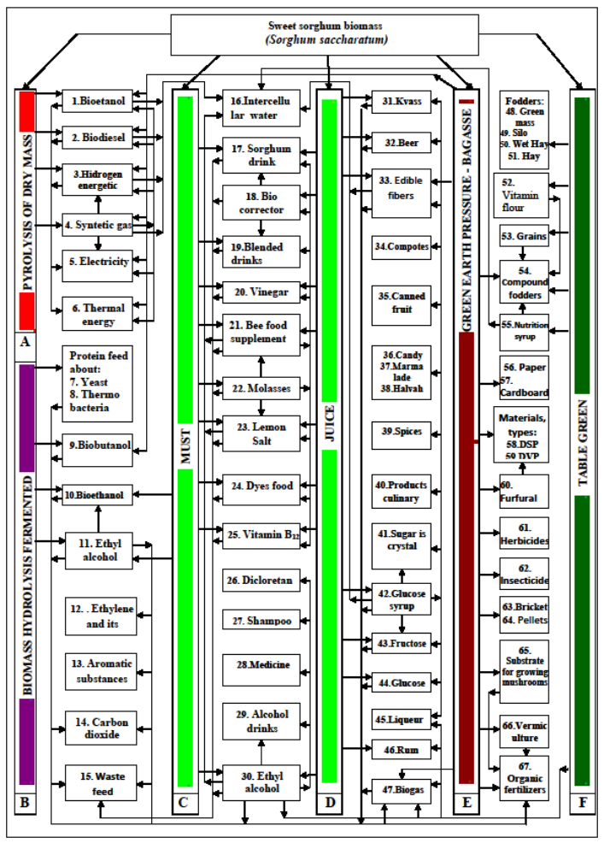
The comparative analysis of sugarcane plants and new-type sweet sorghum hybrids –
Sorgreed – with analog morphological and economic characteristic properties.
Table 1
Indices | Sugarcane, cultivated in the tropical and subtropical countries. | Sweet sorghum hybrids of sugarcane types – Sorgreed, selected in the Republic of Moldova and cultivated in zones with a middle climate, including regionalized hybrids: Porumbeni 4, Porumbeni 5, SASM 1, and SASM 2).
1.Morphological features:  - plant height, cm;  - stalk thickness, mm;  - leaf number;  - leaf height and wideness - up to, cm;  - stalk juiciness. | 350 – 550  25 – 47  25 – 40  (150 – 350) x (30 – 60)  Juicy. | Traditional  330 – 450  18 – 42  18 – 35  (65 – 70) x (8-12) | Sorghum hybrids  180 - 310  8 - 12  10 – 14  (45 – 50) x (6 – 8)
 | 350 – 550  25 – 47  25 – 40  (150 – 350) x (30 – 60)  Juicy. | Juicy, halfdry, dry.
2.Vegetation period:  plantation (sowing) - harvesting | 11 – (18 -24) months | In zones of temperate climate the vegetation period constitutes 4 – 4,5 months, in tropical zones this period is respectively reduced, and it is possible to obtain two – three crops per year.
3. Transpiration coefficient of cultures (kg of moisture for formation of 1 kg of drymass) of the cultures compared. | 1200....1500 | 270 ... 330 (22.0 ... 22.5% of moisture consumption by the sugarcane).  Resistance of Sorgreed hybrids to drought, compared to corn, are demonstrated in fig. 2 and 3.
4. Sugare content in the stem juice at harvesting period . | In tropical zones, the average sugar content in stem juice per years constitutes 14 – 16%, and in subtropical zones it sometimes may lower to 8 – 12%, the sugar degree is represented with saccharose by 100%. | Multiyears average of sugar content in stem juice constitutes 14–16%, and in favorable years – up to 20%, sugars are equally represented through glucose, fructose and saccharose.
5. Plot and soil preparation for young plants transplanting (matured stem segments) or for seed sowing. | Plot planning and basic soil treatment are carried out (2 – 3 deep ploughing and disking) with fertilizers introduction, followed by the repreparation of clods for the young plants transplanting. | Carried out starting from autumn: boghara ploughing and ploughland nivelation,  in spring: harrowing and cultivation before sowing with fertilizers introduction.
6. Harvesting and planting of cuttings, or seeds sowing  (their quantity per 1 ha and the coefficient (k) of reproduction per a square unit) | Planting is carried out mechanically and manually in clods prevently irrigated in the amount of 40 – 60 thous of cuttings per ha (weighting 4-10 t), harvested from the area of 0,1 ha of a vegetation plantation (k=1:10). | Seeds are sowed by a pneumatic seed drill (for corn, as a rule) with a seeding norm of 5 -6 kg/ha of seeds, harvested from 30–50 m² (k=1:250 – 400), and the obligatory trample of the sown field.
7. Handling of the plants of the cultures compared. | During the first year, 10-12 mechanic and 4-5 manual (50-60 day/man/ha) treatments are performed for the destruction of weeds. | 2-3 mechanically treatments are carried out between rows and one manual pulling.
8. Demand for fertilizers (NPK,kg/ha) | 300:150:150 | 100:50:5(30 – 40%, compared to sugarcane)
9.Plant cultivation, when irrigated, in zones with a precepitation norm less than 1300 – 1500mn per year. | Number of irrigations: from 1 -2 to 15 – 20 with a norm of 300 – 400 in sprinkling irrigation and up to 1800 m³/ha by furrow irrigation method. | In middle zones, a water-charging irrigation before sowing is carried out with a norm of up to 600–800 m³/ha and 2-3 irrigations with a norm of 280–320 m³/ha during the vegetation period.
10. Plants resistence to lodging | Taking into consideration the prolonged vegetation period (12–18 months) and the presence of intensive wind storms of hurricane type in these zones, the resistence of plants to lodging is not guaranteed. | Having a reduced vegetation period and a higher content of lignin–cellulose in the stem tissues, the hybrids of Sorgreed ensure the plants resistence to lodging.
11.Adaptation to the mechanical harvesting of the biomass. | As a result of lodging and stem breaking of sugarcane during the intensive winds period, the mechanical and manual harvesting of biomass is often complicated. | Positional verticality of the stalks of the Sorgreed hybrids and their resistence to lodging ensures a favorable suitability to both mechanical and manual biomass harvesting.
12. Productivity in mechanicall biomass harvesting. | During a workday, a special harvesting machine harvests up to 60–90 t of sugarcane stems, thus replacing 30–50 workers. | During 11 hours of work, the harvesting machine by the German company ”KRONE – BIGX” ensures harvesting of 3800 t of crushed biomass of the Sorgreed hyrbrids.
13. Productivity in manual biomass harvesting. | During a workday, one worker harvests up to 5 t of technological stems of sugarcane. | Due to Sorgreed hybrids resistence to lodging, one worker is capable of harvesting 6–7 t of stems per day.
14. Biomass crop capacity, t/ha. | In accordance with the statistic data on sugarcane harvesting by different continents, the average crop capacity of technological stems per 1ha varies from 48 to 60 t (Asia, North and South America), to 70 t (Africa), and 80-90 t (Australia). | During the climatically favorable, years the production of biomass of Porumbeni 4 hybrid without irrigation in the post soviet countries and Romania constituted up to 90-120 t/ha, while as in drought years in south regions of RM, with multianual precipitations norm of 400-500 mm/year – the productivity ranged between 50 and 60 t/ha, and with irrigation 184 t/ha of biomass were obtained.
15. Volume of possible final products, processed from bomass cultivated on 1 ha:  - crystalled sugar  or syrup;  - bioethanol;  - pellets, briquettes;  - biogas, m³;  - feed, feeding units; | 4-10 t of sugar  6-8 t  12-30 t  No information  No information | 14-16 t of cyrop – with irrigation,  7-10 t without irrigation  2.5 – 7.5 t  up to 30-40 t with irrigation, and 8-12 without  up to 18-20 thousand  up to 19-23 t
16. The perspective of implementation and enlargement of the areas of the cultures compared:  - problems of social aspects, environment security, and soil fertility preservation; | Cultivation tehnologies of the sugarcae in tropical countries are accompanied by large expenditures of financial resources, irrational utilization of the natural resources of drinking water and great demand for the utilization of physical human forces for manual biomass harvesting, often carried out in heavy nocive conditions, with a dayly physical energy expenditure of one worker, guantitatively equivalent to a Marathon, and, as a result, such production leads to the recution of life expectancy of manual workers, reduction of soil fertility of exploited soils, and aggravation of ecological, sociological and nutritional conditions in these regions. | Saccharine sorghum hybrids of sugarcane type - Sorgreed, provide: - a high qualitative biomass production; creation of vitally important production units of Sorgreed and new jobs; - utilization of performant, sufficiently mechanized tehnologies for cultivation, harvesting and processing of the biological harvest; - partial restoration of normal ecological condition of the local air basin resulting from the assimilation (fixation) of up to 50-55 t of CO₂ from the atmosphere for the biomass photosynthesis on 1 ha, and eliminating, in turn, in atmosphere up to 25-30 t of O_{2; -} positive ballance of humus in soil of up to 1.5-2 t/ha/year under the monitoring of the root system decomposition process through the introduction of NPK into the soil for the replenishment of the minerals removal by the crop and for the provision of humusification of the roots with carbon.
- perspective of extension of the areas of the cultures compared. | The badly conceived extension of cultivated sugarcane areas in the tropical and subtropical regions intensifies the process of cutting and disparison of tropical forests, diminuation of driking water resources for bioplancton life in costal waters, extension of degradated soil areas, urgentation of global warming as a result of atmosphere pollution with large guantities of CO₂, and as a result – sudden change (aggravation) of the climate in these regions, and even of the whole planet. | Taking into consideration the possible obtaining of large and stable harvests of high-qulity biomass of sweet sorghum hybrids of Sorgreed type in regions with middle climate and the possibility for ecology improvement by this way, it becomes actual and rational to implement the respective hybrids on both parts of the eguator till the lattitude of 50-55, and, first of all, in the regions with a traditional practice of corn cultivation.  Introduction of this innovation in agriculture and mondial economics allows to find efficient variants in the solution of the energetic, ecological, and nutrition problems, which nowdays persist in many countries of the world.

Fig. 2 shows the field of the Sorgreed hybrid SASM 2, cultivated in 2012 in the agricultural cooperative of Hyrtopul Mick village, Criuleni district. Despite the harsh weather conditions of that year, affecting the manifestation of severe soil and air drought during the entire growing season, the hybrid formed biomass harvest of 76.2 t/ha with the sugar content in stem juice of 17%. Corn, under these conditions in the neighboring fields, has formed a relatively small biomass harvest without the seed-bud formation on the cobs (fig. 3).
The percentage of dry matter in the biomass of the hybrid Sorgreed SASM 2 amounted to 32.2%, which contained 15.7 t/ha of fodder units. According to biochemical tests conducted, the amount of crude protein, contained in the dry biomass, can be obtained from 1-1.5 ha of soybean, crude fiber – from 2-3 ha of silage maize, sugar – from 2-3 ha of sugar beet. In favorable years, or under irrigation, Sorgreed hybrids provide a much larger yield.
All above information points to the urgency of ongoing selection works on bringing up the hybrids of sweet sorghum of Sorgreed types and prospects of their application in the production for obtaining food products, feed and bioenergy resources.

Production plantations of sweet sorghum hybrid of Sorgreed type and maize in Agricultural Farming of Hartopul Mic village, Criuleni district of the Republic of Moldova in 2012 (the driest in last 60 years).

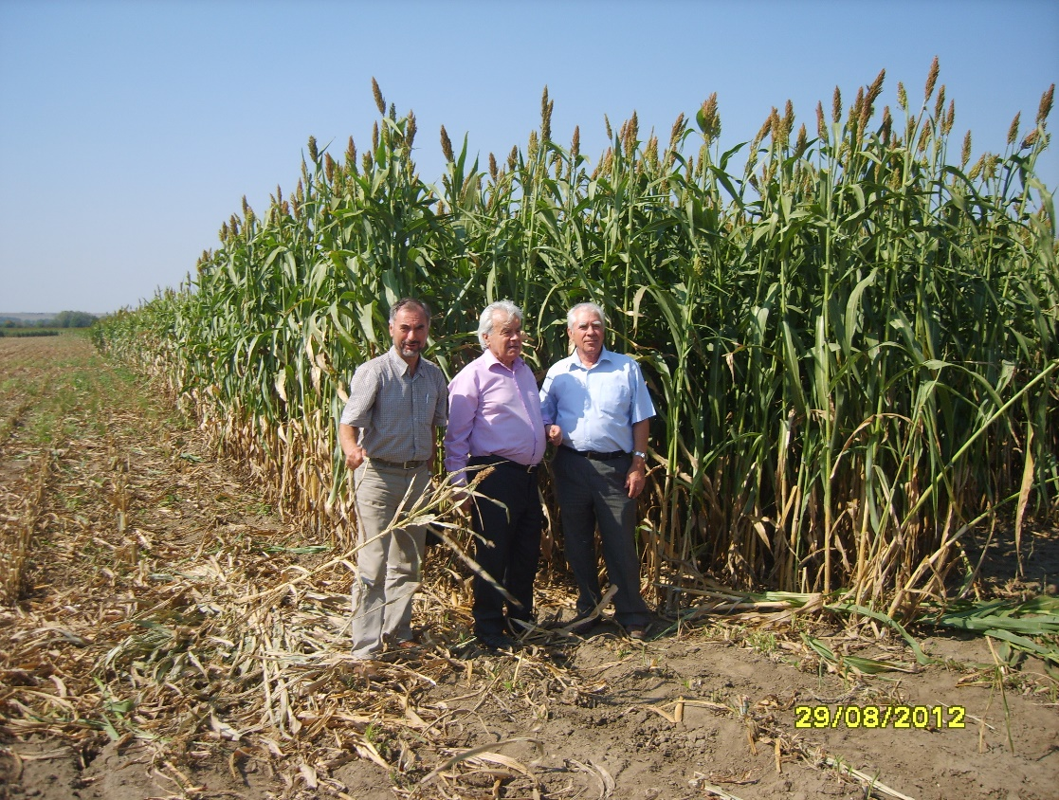
Without
irrigation

Yield -76.2 t/ha.
Juice sugar content - 17%.

Fig. 2. Hartopul Mic, Criuleni district
Hybrid SASM 2

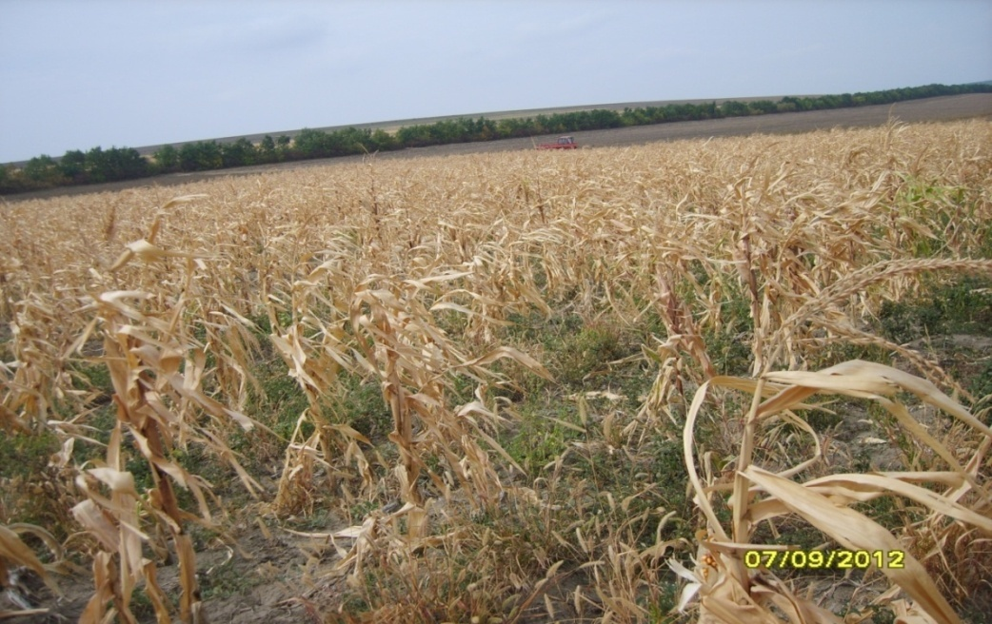
Fig. 3. Corn seed state, without the seed-buds formed
in Hartopul Mic village, Criuleni district, in 2012

